1

#include <stdio.h>

#include <locale.h>

float facsum(int k, int* A) {

float s = 0.0;

int f = 1;

for (int i = 0; i < k; i++) {

s += A[i];

f *= (i + 1);

}

float z = s / f;

return z;

}

int main() {

setlocale(LC_ALL, "ru_RU");

int k = 5, n = 6;

int A[5] = { 1, 2, 3, 4, 5 };

int B[6] = { 2, 3, 4, 5, 6, 7 };

float z = facsum(k, A) + facsum(n, B);

printf("%.2f", z);

return 0;

}

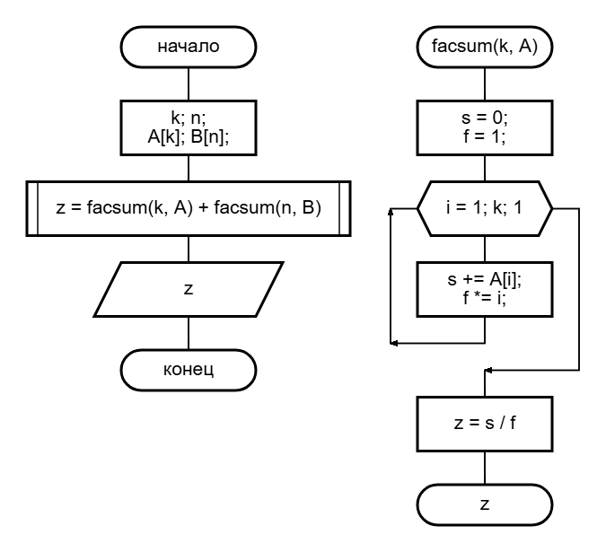

2a

#include <stdio.h>

#include <locale.h>

float min(float a, float b, float c) {

float MIN = a;

if (MIN > b)

MIN = b;

if (MIN > c)

MIN = c;

return MIN;

}

float max(float a, float b, float c) {

float MAX = a;

if (MAX < b)

MAX = b;

if (MAX < c)

MAX = c;

return MAX;

}

void main() {

setlocale(LC_ALL, "ru_RU");

float A, D, E, X, Y, Z;

scanf_s("%f %f %f %f %f %f", &A, &D, &E, &X, &Y, &Z);

float w = (max(X, Y, Z) - min(X, Y, Z)) / (max(A, D, E) + min(A, D, E));

printf("%.2f", w);

}

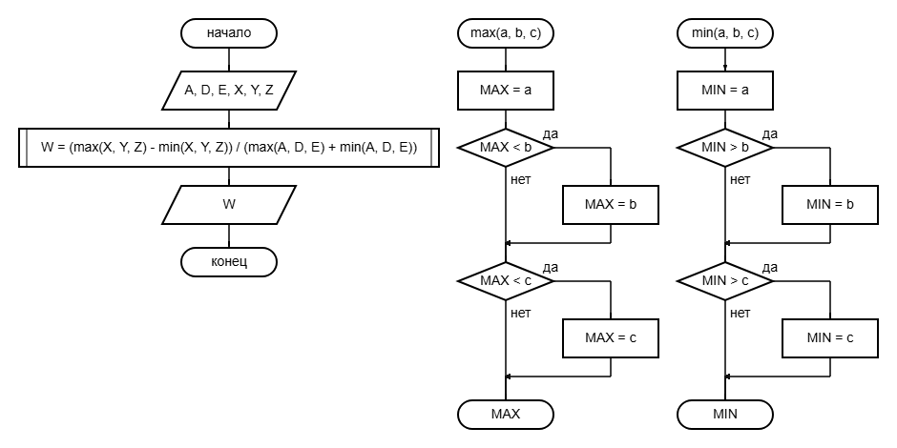

2b

#include <stdio.h>

#include <locale.h>

float minmax(float a, float b, float c, float* min) {

float max = 0;

if (a > b) {

max = a;

*min = b;

}

else {

*min = a;

max = b;

}

if (*min > c)

*min = c;

if (max < c)

max = c;

return max;

}

void main() {

setlocale(LC_ALL, "ru_RU");

float A, D, E, X, Y, Z, min1, min2;

scanf_s("%f %f %f %f %f %f", &A, &D, &E, &X, &Y, &Z);

float w = (minmax(X, Y, Z, &min1) - min1) / (minmax(A, D, E, &min2) + min2);

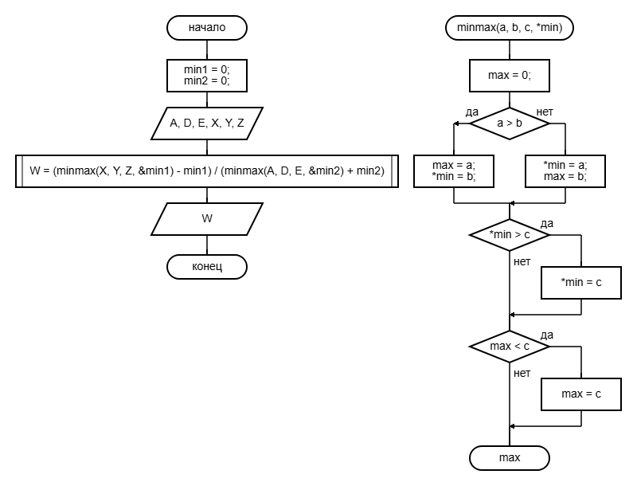

printf("%.2f", w);

}

3

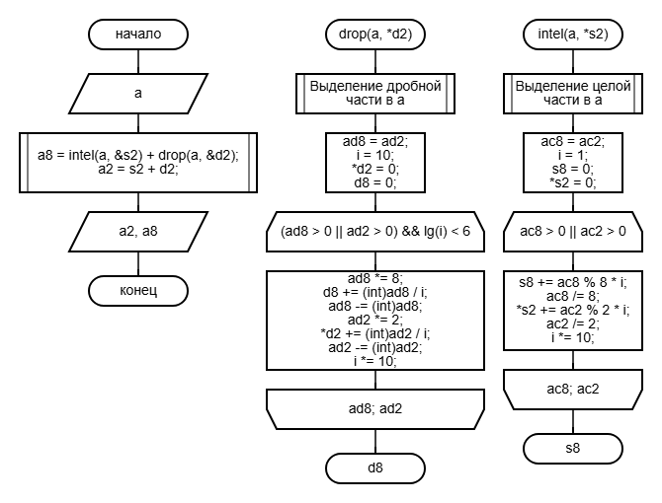

4

#include <stdio.h>

#include <stdbool.h>

int sum(int* A, int* B, int* C) {

int carry = 0;

for (int i = 5; i >= 0; i--) {

int current_sum = A[i] + B[i] + carry;

C[i + 1] = current_sum % 2;

carry = current_sum / 2;

}

C[0] = carry;

return 0;

}

int print_binary(int* A) {

bool has_non_zero = false;

for (int i = 0; i < 7; ++i) {

if (A[i] != 0) {

has_non_zero = true;

}

if (has_non_zero) {

printf("%d", A[i]);

}

}

if (!has_non_zero) {

printf("0");

}

return 0;

}

int main() {

int A[6] = { 1, 0, 1, 1, 1, 1 };

int B[6] = { 0, 1, 0, 1, 1, 1 };

int C[7] = { 0 };

sum(A, B, C);

print_binary(C);

return 0;

}

